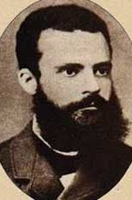
CS 6233 Final Exam Question – Pareto
- Describe what Pareto Analysis is in your own words.
- Write a vague specification for a unit like a game or a calculator or something else. Write the program as fast as you can and make it as long as two pages if possible.
- Write the test plan and conduct the tests.
- Groups the bugs by type[ syntax, math error, typo, vague requirements etc….whatever you think is appropriate. Then form the Pareto chart, and fix only the ones the determined by the method.
- Fix only the bugs determined by the pareto method.
- Include the chart, indicate what types of bugs your fixed and did not fix.
- Summarize the results and note any interesting results. Indicate if the pareto process work for you and why?

